V.KARTHIKEYAN

1911075

1.Create a Bucket in IBM object storage.

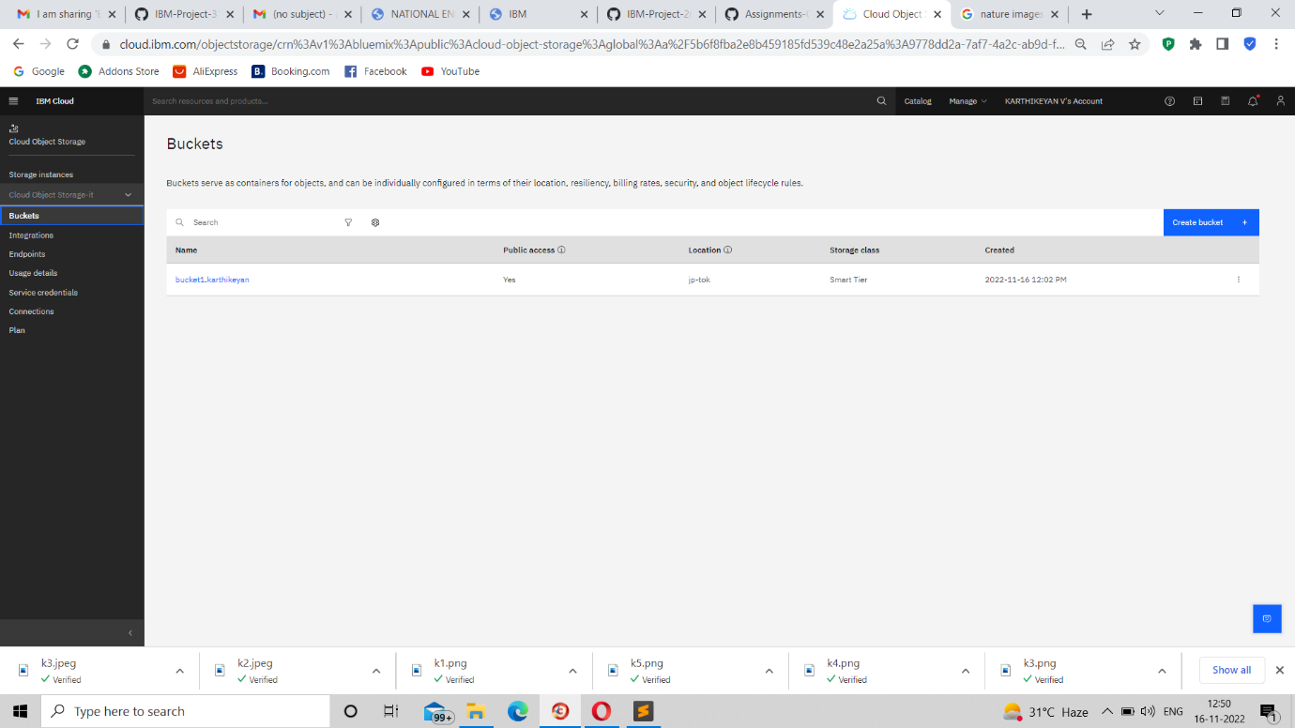

2.Upload an 5 images to ibm object storage and make it public. write html code to displaying all the 5 images.

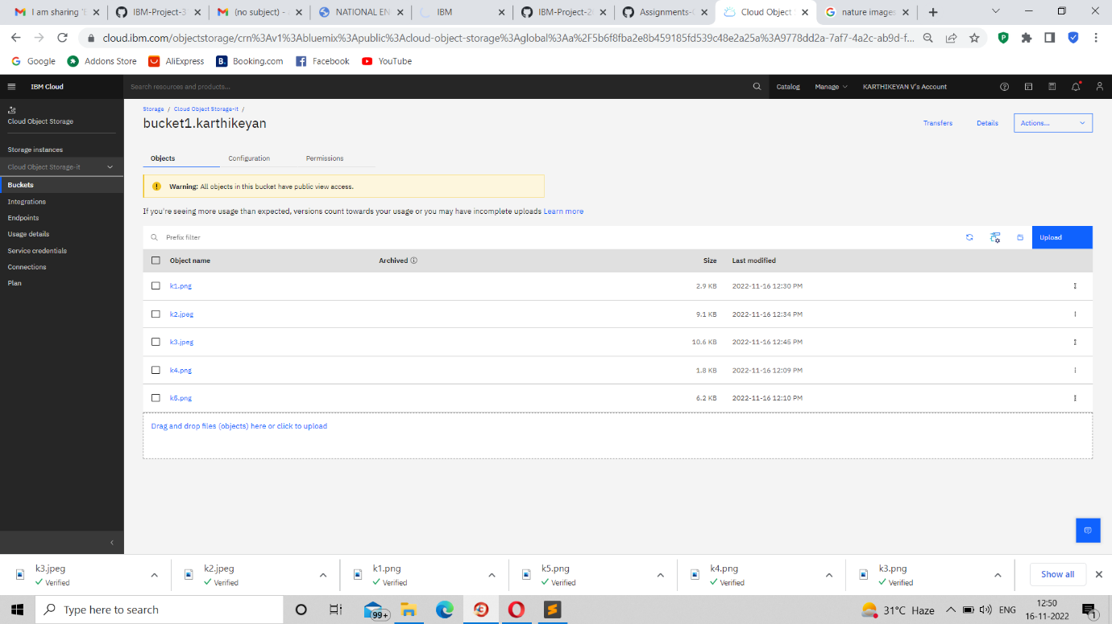

4.Design a chatbot using IBM Watson assistant for hospital. Ex: User comes with query to know the branches for that hospital in your city. Submit the web URL of that chat bot as a assignment

<https://web-chat.global.assistant.watson.appdomain.cloud/preview.html?backgroundImageURL=https%3A%2F%2Fau-syd.assistant.watson.cloud.ibm.com%2Fpublic%2Fimages%2Fupx-8370a385-6639-4058-ba1a-5677ca665384%3A%3A68056daa-9d47-4960-9983-71f8de452949&integrationID=3a9858a4-de32-4b68-ae8e-1fb08cb114cf&region=au-syd&serviceInstanceID=8370a385-6639-4058-ba1a-5677ca665384>